Muhammad Athar Abbas
Sp25-bse-082
Section – A
Lab Week 3:
Task 1:
Centimeters to Yards, Feet, Inches:
Code:
#include <iostream>
#include <cmath>
using namespace std;
int main() {
float length_cm;
cout << "Input the length:" << endl;
cin >> length_cm;
float length_inch = length_cm / 2.54;
int length_inch2 = round(length_inch);
float length_yard = length_inch2 / 36;
float length_feet = (length_inch2 % 36) / 12;
float length_inches = length_inch2 % 12;
cout << length_yard << " yard(s) " << length_feet << " feet(foot) " << length_inches << " inch(es)" << endl;
return 0;

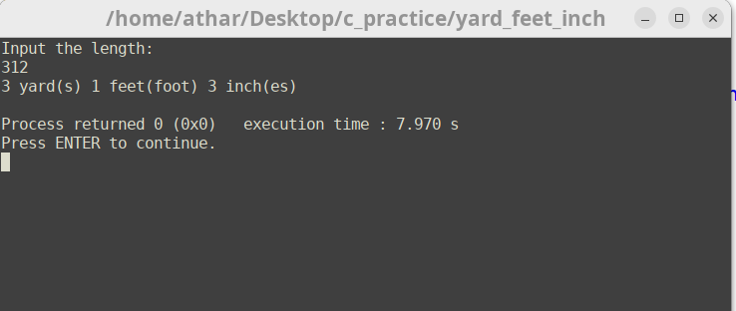
Output:

Task 2:

Elapsed time Conversion:

Code:

#include <iostream>
using namespace std;
int main() {
//Hours , minutes , seconds in seconds
int hours , minutes , seconds;
cout << "Input the time\n";
cout << "Enter Hours ";
cin >> hours;
cout << "Enter minutes ";
cin >> minutes;
cout << "Enter seconds ";
cin >> seconds;
int time_min = (hours * 60) + minutes;
int time_sec = (time_min * 60 ) + seconds;
cout <<"Time in seconds = " << time_sec << endl;
// Seconds in Hours , minutes , seconds
int sec2;
cout << "Enter seconds " << endl;
cin >> sec2;
int hours2 = sec2 / 3600;
int minutes2 = (sec2 % 3600) / 60;
int seconds2 = sec2 % 60;
cout << hours2 << ":" << minutes2 << ":" << seconds2 << endl;
return 0;
}

Output:

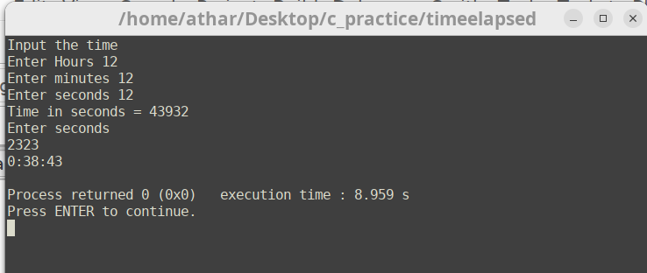
Task 3:

Calculate Net Pay

Code:

#include <iostream>
#include <iomanip>
#include <string.h>
using namespace std;
int main() {
string name;
cout << "Input Name" << endl;
getline(cin,name);
float gross_pay;
cout << "Input Gross pay" << endl;
cin >> gross_pay;
cout << endl << endl;
float federal_tax = gross_pay * 0.15;
float state_tax = gross_pay * 0.035;
float social_security_tax = gross_pay * 0.0575;
float medicare_tax = gross_pay * 0.0275;
float pension_plan = gross_pay * 0.05;
float health_insurance = 75.00;
float total_cut = federal_tax + state_tax + social_security_tax + medicare_tax + pension_plan + health_insurance;
cout << name << endl;
cout << setw(27) << left << setfill('.') << "Gross Amount: " << right << setw(2) << setfill(' ') << '$'<< fixed << setprecision(2)<<setw(7) << gross_pay << endl;
cout << setw(27) << left << setfill('.') << "Federal Tax: " << right << setw(2) << setfill(' ') << '$'<<setw(7) << federal_tax<< endl;
cout << setw(27) << left << setfill('.') << "State Tax: " << right << setw(2) << setfill(' ') << '$'<<setw(7) << state_tax<< endl;
cout << setw(27) << left << setfill('.') << "Social Security Tax: " << right << setw(2) << setfill(' ') << '$'<<setw(7) << social_security_tax<< endl;
cout << setw(27) << left << setfill('.') << "Medicare/Medicaid Tax: " << right << setw(2) << setfill(' ') << '$'<<setw(7) << medicare_tax<< endl;
cout << setw(27) << left << setfill('.') << "Pension Plan: " << right << setw(2) << setfill(' ') << '$'<<setw(7) << pension_plan<< endl;
cout << setw(27) << left << setfill('.') << "Health Insurance: " << right << setw(2) << setfill(' ') << '$'<<setw(7) << health_insurance<< endl;
cout << setw(27) << left << setfill('.') << "Net Pay: " << right << setw(2) << setfill(' ') << '$'<<setw(7) << gross_pay - total_cut << endl;
}
Output:
